CIPAC/4891/m

MT 179.1:
Degree of Dissolution and Solution Stability

Scope
The method is intended for the determination of the degree of dissolution and the solution stability of solid, water soluble formulations.
Outline of Method
The formulation is dissolved in Standard Water in a graduated 250 mL cylinder.
After 15 inversions of the test cylinder and a standing time of 5 min, the degree of dissolution is determined by pouring the content of the test cylinder through a 75 µm sieve. Any residue on the sieve is quantified.
The stability of the solution is checked by allowing the filtrate to stand for a period of 24 h and filtering it again through a 75 µm sieve. Again, any residue on the sieve is quantified.
Reagents
CIPAC Standard Water D, MT 18.1.4, unless otherwise specified
Water, deionised
Apparatus
Sieve, 75 µm, ISO 565 or equivalent (200 mesh according to ASTM E 11-61)
Measuring cylinder, 250 mL with stopper (see Fig. 1). The distance between the graduations 0 and 250 mL should be 20 and 26 cm, and between the 250 mL mark and the bottom of the stopper 3 to 7 cm.
Beaker, 500 mL
Analytical balance, with an accuracy of at least ± 0.1 mg
Glass dishes
Oven or water bath, capable of maintaining a temperature of 60 – 70 °C
Thermometer
Procedure
(i) Preparation of the solution
Calculate the required amount of test sample according to the highest recommended use rate (Note 1). Fill approximately 150 mL Standard Water, with a temperature of 25 ± 5 °C, into the 250 mL cylinder. Weigh the test sample to the nearest 0.01 g (w in (g)), add the test sample to the cylinder and fill to 250 mL with Standard Water. Insert the stopper. Allow to stand undisturbed for 30 s. Then invert the cylinder 15 times (Note 2).
(ii) Degree of Dissolution (5 min test)
Allow the cylinder to stand undisturbed for 5 min at a temperature of 25 ± 5 °C.
After the standing time, transfer the content of the cylinder to a 75 µm sieve and collect the filtrate in a 500 mL beaker for further testing. If any insoluble matter is observed in the cylinder, transfer it quantitatively to the sieve by washing the cylinder with deionised water. Discard the wash water.
Weigh a glass dish to the nearest 1 mg (a in [mg]). Transfer any residue from the sieve to the glass dish with deionised water from a wash bottle. Dry to constant weight (Note 3) and record the weight of the glass dish to the nearest 1 mg (b in [mg]). Calculate and report the residue (Note 4).
(iii) Solution Stability (24 h test)
Allow the 500 mL beaker (with the filtrate) to stand undisturbed for 24 h at 25 ± 5 °C. After the standing time, pour the content of the 500 mL beaker through a 75 µm sieve. Rinse the beaker with deionised water and transfer the rinsate to the sieve.
Weigh a glass dish to the nearest 1 mg (a’ in [mg]). Transfer any residue from the sieve to the glass dish with deionised water from a wash bottle. Dry to constant weight (Note 3) and record the weight of the glass dish to the nearest 1 mg (b’ in [mg]). Calculate and report the residue (Note 4).

(iv) Calculation
$$Residue after 5 min =\frac{\left(b-a\right) x 100 \%}{w}$$

$$Residue after 24 h =\frac{\left(b'-a'\right) x 100 \%}{w}$$

Where:
a and a’ = weight of the glass dish
b and b’ = weight of the glass dish plus the dried residue
w = weight of the sample taken

Note 1: If the highest recommended use rate is less than 1.2 % w/v, then the test shall be carried out at 1.2 % w/v (corresponding to 3 g sample weight).
Note 2: The expression ‘invert the cylinder’, as used above, implies that the stoppered cylinder is turned by hand through 180 degrees and is brought back to its original position, the whole operation being completed in approximately 2 s.

Note 3: A temperature of 60 – 70 °C is recommended. If necessary, the temperature must be varied to avoid decomposition of the active ingredient or volatilisation of the residue at the drying temperature.

Note 4: The gravimetric analysis can be misleading when formulations with insoluble inerts do not completely disintegrate and disperse.

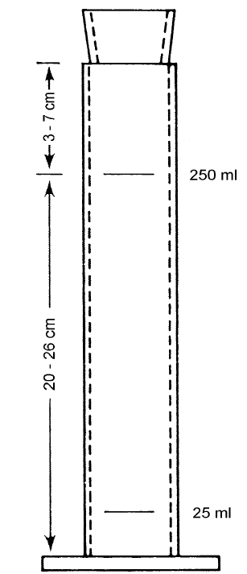

Fig. 1: Measuring cylinder (BS EN ISO 4788:2005)

